This exam covers topics such as matrix operations, vector spaces, linear transformations, inner products, and eigenvalues. Below is my understanding of the questions and my solution approach.

Q1
- We need to determine the quadratic polynomial 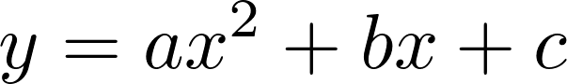 through three given points. It has two steps: first, set up a linear system for coefficients a, b, and c based on the property that the polynomial passes through the points; second, solve the system using row operations on the augmented matrix.
(b) For a linear system with parameter k, we need to discuss the values of k for which the system has no solution, a unique solution, or infinitely many solutions. This depends on the relationship between the rank of the augmented matrix and the rank of the coefficient matrix.

Solution Approach
(a)(i) Set up the linear system: Substitute the three points (1,2), (-1,6), and (2,3) into the polynomial respectively. Using the property that the polynomial equation holds true for these points, we get the system:
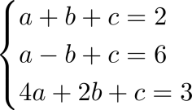

(a)(ii) Solve the augmented matrix with row operations: Construct the augmented matrix 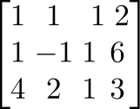. Follow the steps: Scale the pivot row→Eliminate non-pivot elements in the column→Back-substitute to solve. Specific row operations include and to eliminate non-pivot elements in the first column. Then scale the pivot with 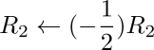. Later, eliminate non-pivot elements in the second column and back-substitute to get the values of a, b, and c.

(b) Use the properties of upper triangular augmented matrices. Judge based on the non-zeroness of pivots and the relationship between zero rows and the right-hand side:

Unique solution: All pivots are non-zero, so 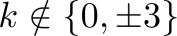. At this time, the rank of the coefficient matrix equals the number of variables, and the system has a unique solution.

Infinitely many solutions: There is a zero row with a zero right-hand side. That is, 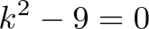 and , so . The rank of the coefficient matrix equals the rank of the augmented matrix but is less than the number of variables, so there are free variables.

No solution: There is a zero row with a non-zero right-hand side. That is, (right-hand side is -6) or (contradictory solution occurs). The rank of the coefficient matrix does not equal the rank of the augmented matrix, so the system has no solution.

Q2
- Calculate the matrix determinant using cofactor expansion. Choose an appropriate row or column (prefer rows/columns with more zero elements) to simplify calculations.
(b) Given 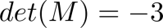 for matrix 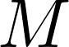, prove the property of the inverse of the transpose 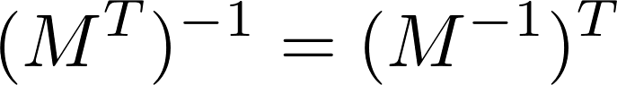, calculate 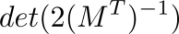, and determine the rank of 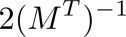. It tests core properties of matrix determinants, transposes, inverses, and rank invariance.

Solution Approach:
- Choose the third column (with more zero elements) for expansion. For each element , compute its minor 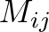 (the determinant after deleting the i-th row and j-th column). Multiply by the sign factor 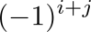 to get the cofactor 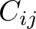. Finally, sum up by 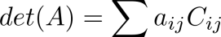 to get the determinant result.

(b)(i) Use the matrix operation property 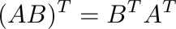 and 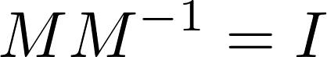 (identity matrix). Take the transpose of both sides of to get 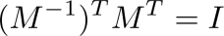. By the definition of inverse matrices, prove .

(b)(ii) Apply two core formulas. First, 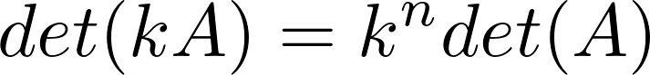 (where  is the matrix order). Second, 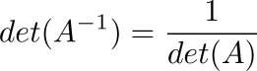. Since 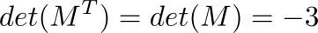, we have 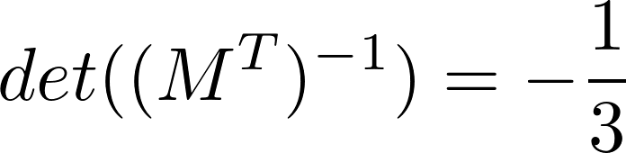. Substitute the scalar 2 to get 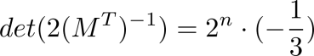.

(b)(iii) Invertible matrices have full rank . Transposition, inversion, and scaling by non-zero scalars do not change the rank. Since is invertible, 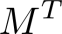 and 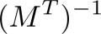 are also full rank. Multiplying by 2 keeps the rank as .

Q3
- Prove the cyclic symmetry of the scalar triple product using determinant row operations. The core is to connect the scalar triple product with the determinant and the effect of row operations on the determinant.
- Given the coordinates of three triangle vertices, calculate the triangle area (using the geometric meaning of the cross product) and a unit vector perpendicular to the triangle plane (unitizing the normal vector from the cross product).

Solution Approach:
(a) Prove the scalar triple product: Express the scalar triple product as the determinant 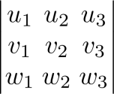. Perform two row swaps: first swap Row 1 and Row 3, then swap Row 2 and Row 3. The determinant sign changes twice and returns to the original. Finally, get the determinant 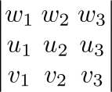, which corresponds to 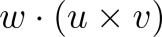. Complete the proof.

(b)(i) Calculate the triangle area: First, construct vectors corresponding to two sides of the triangle (such as  and ). Compute their cross product. The magnitude of the cross product equals the area of the parallelogram with the two vectors as adjacent sides. The triangle area is half of this magnitude: 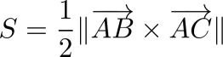.

(b)(ii) Find the unit normal vector: The cross product 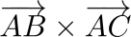 is the normal vector of the triangle plane. Divide it by its magnitude to get the unit normal vector 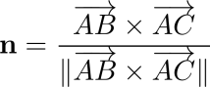. Both positive and negative directions are acceptable.

Q4
Given two lines 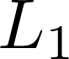 and 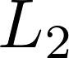 in 3D space, determine their positional relationship (parallel, intersecting, or skew). It tests the parametric representation of lines, the properties of direction vectors, and the solution of systems of equations. Analyze in the logical order: First judge parallelism → Then judge intersection → Finally confirm skewness.

Solution Approach:
- Parameterize the lines and extract direction vectors: Express the two lines as parametric equations. Let the parameter of be t and the parameter of be s. Extract their direction vectors 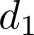 and 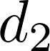 respectively.

2. Judge if the lines are parallel: If there is a non-zero constant 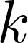 such that 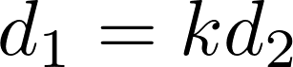, the lines are parallel; otherwise, they are not. In this question, the direction vectors are not scalar multiples, so the two lines are not parallel.

3. Judge if the lines intersect: Set the parametric equations of the two lines equal to get a system of equations for t and s. Solve the system. If there is a unique solution satisfying all coordinate equations, the lines intersect; otherwise, they do not. In this question, the system has no solution, so the two lines do not intersect.

- Determine the positional relationship: Lines in 3D space that are neither parallel nor intersecting are skew lines.

Q5
- A non-standard addition operation is defined in the vector space 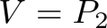 (quadratic polynomial space). Find the zero vector (additive identity) and the additive inverse of any polynomial  based on their definitions.
(b) Given two sets, judge if they are subspaces of the corresponding vector spaces using the subspace test (containing the zero vector and being closed under linear combinations). If not, construct a counterexample.

Solution Approach:
(a)(i) Find the zero vector: The zero vector e satisfies for any 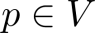. Combined with the non-standard addition rule , we get 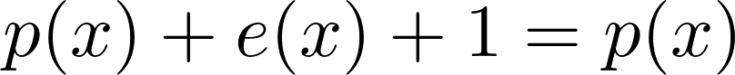. Solve for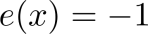. So the zero vector is the constant polynomial -1.

(a)(ii) Find the additive inverse: Let q be the additive inverse of , satisfying 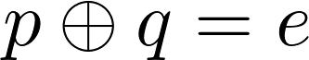. Substitute the addition rule: . Solve for 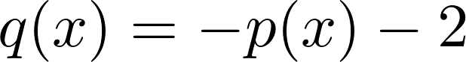. So the additive inverse of is .

(b) Judge subspaces:

Set : The zero vector 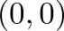 does not satisfy the equation 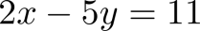. It fails the necessary condition of subspaces (containing the zero vector), so it is not a subspace of .

Set (solution space of the linear differential equation 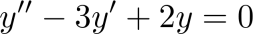): Express it as the kernel space 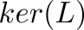 of the linear operator 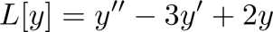. Verify that the zero vector satisfies the equation (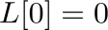). For any 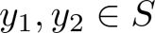 and scalars 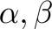, we have . It is closed under linear combinations, so it is a subspace of 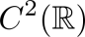.

Q6
- Given a set of polynomials, judge if they span 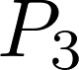 (cubic polynomial space) and if they form a basis for . It tests the definition of span (any element can be linearly represented) and the definition of basis (linearly independent and spanning the space).
- Find the basis of the subspace of 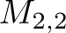 (2×2 matrix space) satisfying the constraint 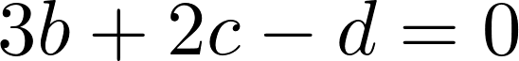.
- Given a matrix and its row echelon form, find the bases and dimensions of the row space and column space, and give a geometric interpretation of the column space.

Solution Approach:
(a)(i) Judge if the polynomials span : Let any . Assume . Match the coefficients of 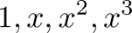 to get a linear system. The coefficient matrix is upper triangular with non-zero diagonal elements (non-zero determinant), so the system has a unique solution. Thus, the set of polynomials spans .

(a)(ii) Judge if it is a basis: The dimension of is 4. There are 4 polynomials in the set, and they are linearly independent (non-zero determinant of the coefficient matrix). It satisfies linearly independent + spanning the space + number of vectors = space dimension, so it forms a basis for .

(b) Find the basis of the subspace: From the constraint , we get . Express any matrix in the subspace as:
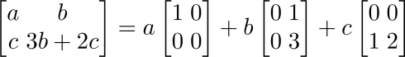
Extract the coefficient matrices as basis vectors: 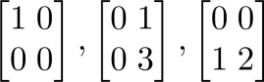. The dimension of the subspace is 3.

(c) Row space basis: Non-zero rows of the row echelon form are the basis of the row space. Row operations do not change the row space, so directly take the non-zero row vectors.

Column space basis: Pivot columns (columns with leading 1s) of the row echelon form correspond to columns of the original matrix. These column vectors form the basis of the column space.

Geometric interpretation: If the dimension of the column space is 3 (corresponding to a 3-row matrix), the column space is 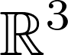 (the entire 3D space).

Q7
The linear transformation : 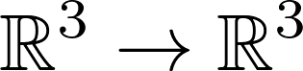 is defined as . Find its standard matrix representation, determine the kernel and image with geometric interpretations, calculate the rank and nullity, and judge if is invertible. It tests the matrix representation of linear transformations, the definitions of kernel and image, and the Rank-Nullity Theorem.

Solution Approach:
(a) Find the standard matrix representation: The standard matrix of the cross product linear transformation has a fixed form. For 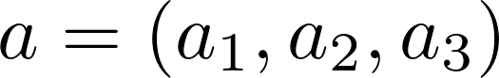, the matrix is:
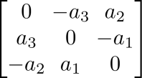
Substitute 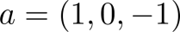 to get the standard matrix 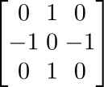.

(b) Find the kernel and image with geometric interpretations:

Kernel: All x satisfying 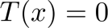, i.e., . This is equivalent to  being collinear with . So . Geometrically, it is a line passing through the origin and parallel to .

Image: All values of 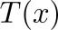, i.e., the set of vectors perpendicular to (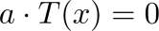). So . Geometrically, it is a plane passing through the origin and perpendicular to .

(c) Calculate the rank and nullity: The nullity is the dimension of the kernel (1). The rank is the dimension of the image (2). It satisfies the Rank-Nullity Theorem: (dimension of ).

(d) Judge invertibility: A linear transformation is invertible if and only if its kernel contains only the zero vector (nullity = 0). Here, nullity = 1 ≠ 0, and rank = 2 < 3 (not full rank). So is not invertible.

Q8
Given the transition matrix  from basis 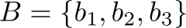 to basis 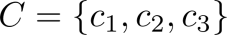, find the coordinate vectors of vectors in  under , the coordinate of the specific vector 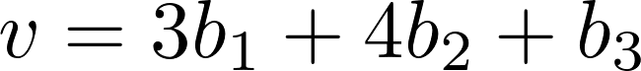 under , the coordinate of the vector 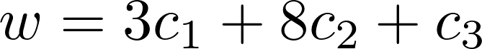 under , and analyze the relationship between 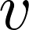 and . It tests the definition of transition matrices, the linearity of coordinate vectors, and the application of inverse transition matrices.

Solution Approach:
- Find coordinates of vectors in under : Column vectors of the transition matrix are the coordinate vectors of 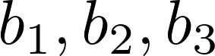 under basis . That is,
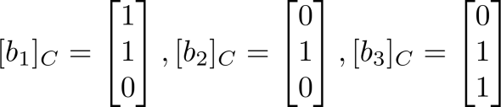.

(b) Find the coordinate of under : Use the linearity of coordinate vectors. . Substitute the coordinate vectors to calculate 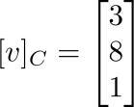.

(c) Find the coordinate of under : First, find the inverse transition matrix 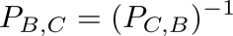. The transition matrix satisfies . Substitute the coordinate of under (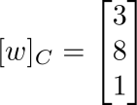) to calculate 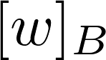.

- Analyze the relationship between and : 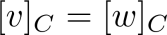 and is the coordinate of under . So and are the same geometric vector, only with different coordinate representations under different bases.

Q9
- Given a 5×3 matrix , Logan claims the null space is 2-dimensional, and Sia claims the column space is 2-dimensional. Judge if both can be correct. It tests the application of the Rank-Nullity Theorem.
- Find the singular values of matrix 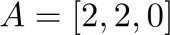. It tests the definition of singular values.
(c) Prove that a unitary matrix  satisfies 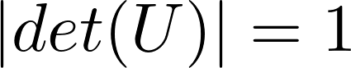. It tests the definition of unitary matrices and properties of determinants.

Solution Approach:
(a) Judge the rationality of the conclusions: According to the Rank-Nullity Theorem, for an 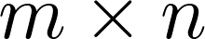 matrix, . For a 5×3 matrix,. If the null space is 2-dimensional, then 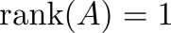. The dimension of the column space equals the rank. If the column space is 2-dimensional, then 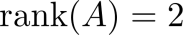. This is a contradiction, so they cannot both be correct.

(b) Find the singular values: Singular values are the square roots of the eigenvalues of . First, calculate 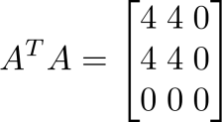. Find its eigenvalues: 8, 0, 0. So the singular values are and 0 (singular values are non-negative, sorted in descending order).

- Prove the property of unitary matrices: A unitary matrix satisfies  (where  is the conjugate transpose). Take the determinant of both sides: . Also, 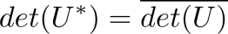. So 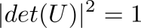, which means .

Q10
Given a symmetric matrix , find its eigenvalues, bases of eigenspaces, geometric multiplicities, and express as 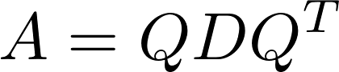 (where  is an orthogonal matrix and  is a diagonal matrix). It tests the eigenproperties of symmetric matrices, the solution of eigenvalues and eigenvectors, and the orthogonal diagonalization method.

Solution Approach:
(a) Find the eigenvalues: Partition into a 1×1 block  and a 2×2 block 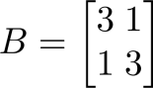. Eigenvalues of a block diagonal matrix are the union of eigenvalues of each block. For , calculate the characteristic polynomial . Solve for eigenvalues 2 and 4. So eigenvalues of are 2 (algebraic multiplicity 2) and 4 (algebraic multiplicity 1).

(b) Find bases of eigenspaces:
For 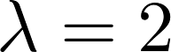: Solve 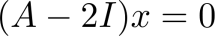. Get the basis of solutions 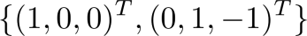, which is the basis of the eigenspace.

For 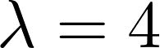: Solve 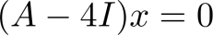. Get the basis of solutions 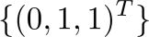, which is the basis of the eigenspace.

(c) Find geometric multiplicities: Geometric multiplicity is the dimension of the eigenspace. The geometric multiplicity of is 2, and the geometric multiplicity of is 1. For symmetric matrices, geometric multiplicity equals algebraic multiplicity.

(d) Orthogonal diagonalization: Unitize the eigenvectors to get an orthonormal set of vectors. Construct the orthogonal matrix (column vectors are unit eigenvectors) and the diagonal matrix (diagonal elements are corresponding eigenvalues):
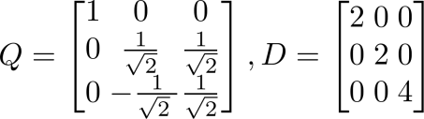
It satisfies .

Q11
- Prove the conjugate symmetry of the Hermitian inner product 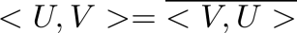.
(b) Given two complex matrices  and , calculate the length of , the distance between and , and the angle between them using the Hermitian inner product. It tests the definition and properties of the Hermitian inner product.

Solution Approach:
- Prove conjugate symmetry: According to the definition of the Hermitian inner product , calculate the conjugate
. Complete the proof.

(b) Length: . Substitute the elements of to calculate the length.

Distance: 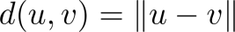. First calculate the elements of , then substitute into the length formula.

Angle: 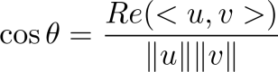. First calculate the real part of the inner product , then substitute the length values to calculate the cosine of the angle.

Q12
- Judge if the binary operation is an inner product on . Verify the four inner product axioms.
- Calculate 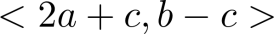 using inner product properties.
(c) Find an orthonormal basis of the subspace of 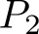 using the Gram-Schmidt method. It tests inner product axioms, the linearity of inner products, and the orthogonalization method.

Solution Approach:
(a) Judge the inner product: Verify the four inner product axioms (symmetry, linearity, non-negativity, positive definiteness):

Symmetry and linearity: Satisfied (the coefficient matrix is symmetric in matrix form, and the operation conforms to linear properties).

Non-negativity and positive definiteness: Take 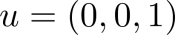. Then 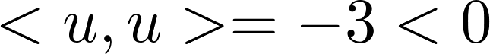, which does not satisfy non-negativity. So it is not an inner product.

(b) Calculate the inner product: Expand using the linearity and symmetry of inner products:
Substitute the given conditions: . Calculate the result as -12.

(c) Gram-Schmidt orthogonalization:
Orthogonalization: Suppose the subspace is spanned by 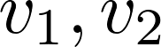. First take . Then calculate 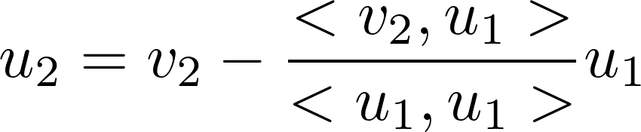 to ensure 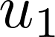 and 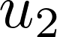 are orthogonal.

Unitization: Divide and by their lengths respectively to get the orthonormal basis 

